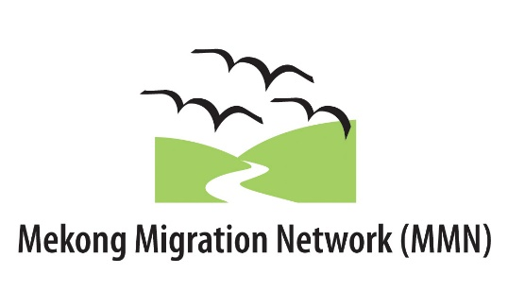

ASEAN ADVOCACY TRAINING 2016 - MEMORANDUM OF AGREEMENT
The MMN Memorandum of Agreement must be signed by both the Director of the organization and by the Candidate.
Candidate’s last (family) name: | First name: | Country:
The Organization confirms that the Candidate named below:
Has been an active employee/volunteer with the organization for at least 1 year
Is capable of communicating effectively in English
Is committed to fully participating in all Program activities Personally completed the application form

The Organization agrees to:
Assist the Candidate, if accepted, to fully prepare for and participate in the Program and to carry out the related follow-up activities.
Name of Organization:
Name of Director:
Director’s signature: |  | Date (dd/mm/yyyy):
The Candidate:
If I am accepted as a participant in the Program I agree to:
- complete the relevant Program preparation;
- attend and participate fully in all sessions and activities that are part of the required Program;
- develop a plan to transfer the learning acquired through the ASEAN Advocacy Training and return to my organization to implement it;
- participate in all evaluation activities during the Training and after its completion; and
- commit to contribute in the future advocacy work carried out by MMN.

I understand that failure to comply with any of the above may result in not receiving a certificate of participation.
Candidate’s signature: |  | Date (dd/mm/yyyy):

