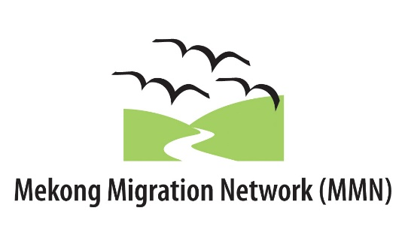

2016 ASEAN ADVOCACY TRAINING

4-8 June 2016
Bangkok, Thailand

Application Form

Application deadline: 27 March 2016
Your Application must include all of the documents listed below:
□1. The completed Application Form (Part A completed by the Director of the Candidate’s organization; Part B completed by the Candidate)
□2. The Memorandum of Agreement duly signed by the Candidate and the Director of the Candidate’s organization

All documents should be sent by email (the signed Memorandum of Agreement should be scanned and sent by email).
The Candidate’s name, country and the name of the organization must appear on all documents.
Please save the Application Form the following way before emailing it back to us: country_last name of candidate.doc (for example: thailand_boonlert.doc)
Send all the required documents before the deadline in order to facilitate the processing of your application. Send the application form in Word format.

The deadline for submitting applications is 27 March 2016.
Email address: application@mekongmigration.org

2016 MMN ASEAN ADVOCACY TRAINING
APPLICATION FORM

Please be sure to complete all sections of the application form and to answer each question fully. Incomplete applications will not be processed.

CANDIDATE NOMINATED
Last (family) name (as it appears on your passport): | First name (as it appears on your passport):
Gender:  Male Female | Work email (of the Candidate): Personal email (of the Candidate):
Telephone:  Cell /Mobile phone : | Skype ID:
Home address:

PART A: PROFILE OF CANDIDATE’S ORGANIZATION (to be completed by the Director of the organization)
1. Name of organization:
2. Name of Director:
3. Mailing address of the organization:
Number: | Street: |  | P.O. Box:
City: |  | Province/State:
Postal Code: |  | Country:
4. Telephone: |  | 5. Social Media of the organization (Facebook, Twitter, etc.):
6. Email (of the organization): |  | 7. Email (of the Director):
8. Website:
9. Year in which organization was established:
10. Number of staff: Full time Part time |  | 11. Number of volunteers:
12. Please indicate what types of activities your organization focuses on.
Outreach work Policy analysis, advocacy
Research Service provision
Emergency response Education
Others (Please specify) ________________________________________________________________

ACTIVITIES
13. Please list your organization’s three (3) main areas of activity (in order of priority)
1.
2.
3.
14. Please describe the main advocacy activities undertaken by your organization, and the Candidate’s roles in these.

15. Please describe how your organization has worked on ASEAN advocacy.

16. Please describe how your organization would benefit from the Candidate’s participation in the ASEAN Advocacy training.

PART B: PROFILE OF CANDIDATE (To be completed by the Candidate)
17. Last (family) name: | First name:
18. Job title within your organization:
19. Status: Staff Volunteer
20. How long have you been working with this organization?
21. Description of overall responsibilities:
22. Please describe how you will personally benefit from the participation in the ASEAN Advocacy training.
23. Please describe how you plan to apply the knowledge and skills obtained at the training to the advocacy work carried out by your organization.

24. Please describe how you plan to contribute the knowledge and skills obtained at the training to the advocacy work carried out by MMN.

LANGUAGE
27. Your mother tongue
28. Language proficiency in English (Please check the appropriate level):
Ability to understand Ability to speak Ability to read
Understand without difficulty | Speak fluently and accurately | Read fluently
Understand almost everything (if addressed slowly) | Speak intelligibly  (but not always accurate) | Read slowly
Require a lot of translation and repetition | Speak with difficulty (often looking for words) | Read with difficulty (needs dictionary)

